**Competitive Adsorption Simulation of Nitrogen and Hydrogen**

Yufei Chen

1. **Introduction**

Ammonia (NH3) is an inorganic chemical compound with great applications in agriculture, which can be used for producing fertilizers and increasing the yields of crops such as maize and wheat. The Haber-Bosch process is the most widely used method for industrial production of ammonia. The method was first invented by German chemist Fritz Haber in the early 20th century and was first utilized on an industrial scale in Germany during World War I. In 1918, Fritz Haber was awarded the Nobel Prize in Chemistry "for the synthesis of ammonia from its elements".

Grand canonical Monte Carlo (GCMC) simulation is a method that samples the phase space by generating "guess configurations" for possible transitions into new states and accepting moves based on transition probabilities, allowing for the reproduction of the statistical distribution of all possible states in a system. It has been widely used as the most convenient and powerful tool to study the adsorption properties of gases and their mixtures in porous materials, such as metal-organic framework (COF).

In this project, we use a GCMC simulation to study competitive adsorption of two different adsorbate species (hydrogen and nitrogen) on a two-dimensional (2D) square lattice (catalyst surface). By varying interaction energies to explore different adsorption scenarios, this GCMC simulation can help us understand the competitive adsorption of nitrogen and hydrogen on the catalyst surface and provide insights into the optimal conditions for the Haber-Bosch process.

1. **Methodology**

**2.1 Model Description**

In the GCMC simulation, the catalyst surface was modeled as a 2D square lattice of size *N* × *N*,with *N* = 10, 25, 50, 75, and 100. The lattice sites can be occupied by hydrogen (particle A), nitrogen (particle B), or remain empty (0). The adsorption process was simulated using a GCMC method, where the chemical potentials of the gases and the temperature will influence the process of adsorption.

**2.2 Simulation Parameters**

We didn’t know the exact values of the adsorption and interaction energies for hydrogen and nitrogen, so in order to understand the system’s behavior, we explored the following 5 sets of parameters representing 5 different types of interactions between hydrogen and nitrogen:

1. Ideal mixture of nitrogen and hydrogen:

εN = -0.1 eV, εH= -0.1 eV

εNN = 0 eV, εHH= 0 eV, εNH= 0 eV

1. Repulsive interactions between nitrogen and hydrogen:

εN = -0.1 eV, εH= -0.1 eV

εNN = 0.05 eV, εHH= 0.05 eV, εNH= 0.05 eV

1. Attractive interactions between nitrogen and hydrogen:

εN = -0.1 eV, εH= -0.1 eV

εNN = -0.05 eV, εHH= -0.05 eV, εNH= -0.05 eV

1. Immiscible nitrogen and hydrogen:

εN = -0.1 eV, εH= -0.1 eV

εNN = -0.05 eV, εHH= -0.05 eV, εNH= 0.05 eV

1. “Like Dissolves Unlike” scenario:

εN = -0.1 eV, εH= -0.1 eV

εNN = 0.05 eV, εHH= 0.05 eV, εNH= -0.05 eV

In these sets of parameters, εN represents the adsorption energy of nitrogen, εH represents the adsorption energy of hydrogen, εNN, εHH, and εNH are interaction energy between nitrogen and nitrogen, hydrogen and hydrogen, and nitrogen and hydrogen, respectively.

For each set of parameters, we varied the chemical potential of hydrogen (*μ*H) from -0.2 eV to 0 eV, while keeping the chemical potential of nitrogen (*μ*N) constant at -0.1 eV. The temperature (*T*) varied from 0.01/k to 0.019/k, where k is the Boltzmann constant in its eV form (k = 8.617 × 10-5 eV/K).

**2.3 Grand Canonical Monte Carlo Simulation**

The GCMC simulation consists of the following procedures:

1. Initialize the lattice:

Set up the empty 2D lattice (size: *N* × *N*) by using “np.zeros”.

1. Compute neighbor indices with periodic boundary conditions.
2. Calculate interaction energy:

Pick up an occupied lattice site, determine the type of the particle and its neighboring particle, and then calculate their interaction energy.

1. Add or remove a particle:
2. Decide whether to add or remove a particle with equal probability; (2) randomly select a lattice site; (3) decide which particle to add (or remove) with equal probability; (4) calculate energy change; (5) use the Metropolis criterion to accept or reject the move based on the Boltzmann factor.
3. Run the simulation.

The GCMC simulation runs for 10,000 steps, after the simulation, phase diagrams and lattice configurations were plotted, and the results were analyzed and discussed.

1. **Results**

The phase diagrams and lattice configurations for each set of parameters were generated by GCMC simulation. The phase diagrams show the mean coverage of hydrogen (<θH>), nitrogen (<θN>), and total coverage (<θH> + <θN>) at different temperatures and chemical potentials of hydrogen (*μ*H). The final lattice configurations indicate the distinct adsorption pattern at *μ*H = -0.2 eV, *μ*H = -0.1 eV, and *μ*H = 0 eV for each scenario.

The simulated phase diagrams and lattice configurations of the competitive adsorption on a 50 × 50 lattice surface will be presented and discussed in the following context, and the phase diagrams and lattice configurations of other lattice sizes (*N* = 10, 25, 75, and 100) will be included in the supporting information.

**3.1 Ideal Mixture**

When nitrogen and hydrogen are an ideal mixture, there are no interactions between gas particles (εNN = εHH= εNH= 0 eV). As Figure 1 shows, the mean coverage of hydrogen (<θH>) increases with increasing chemical potentials of hydrogen (*μ*H), while the mean coverage of nitrogen (<θN>) decreases. Combined, the total coverage of nitrogen and hydrogen (<θH> + <θN>) increases smoothly with increasing *μ*H, and the lattice sites were randomly occupied by nitrogen or hydrogen gas particles, showing no preference for specific species.

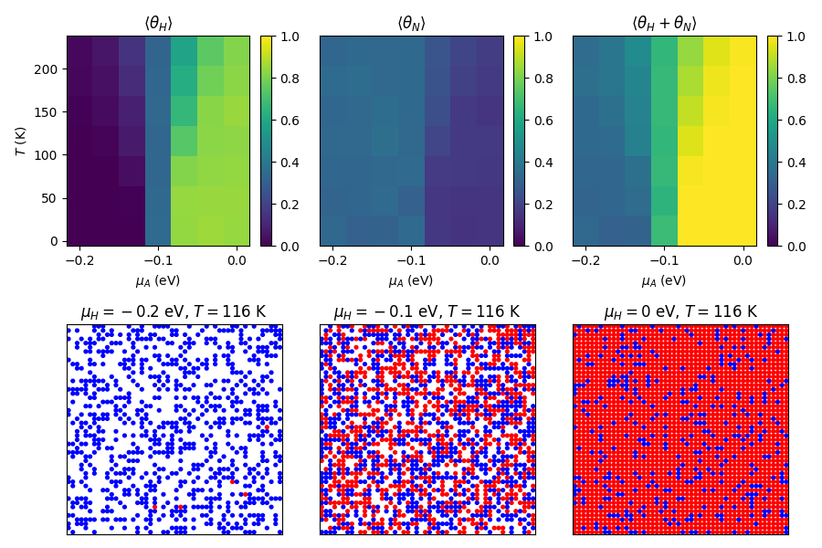

**Figure 1.** Phase diagrams and lattice configurations for ideal mixture of nitrogen and hydrogen (lattice size: 50 × 50, blue circle represents nitrogen, red circle represents hydrogen).

**3.2 Repulsive Interactions**

When there are repulsive interactions between nitrogen and hydrogen (εNN = εHH= εNH= 0.05 eV), occupying the lattice site next to a gas particle will be difficult, so the total coverage of nitrogen and hydrogen decrease dramatically compared to the ideal mixture scenario.

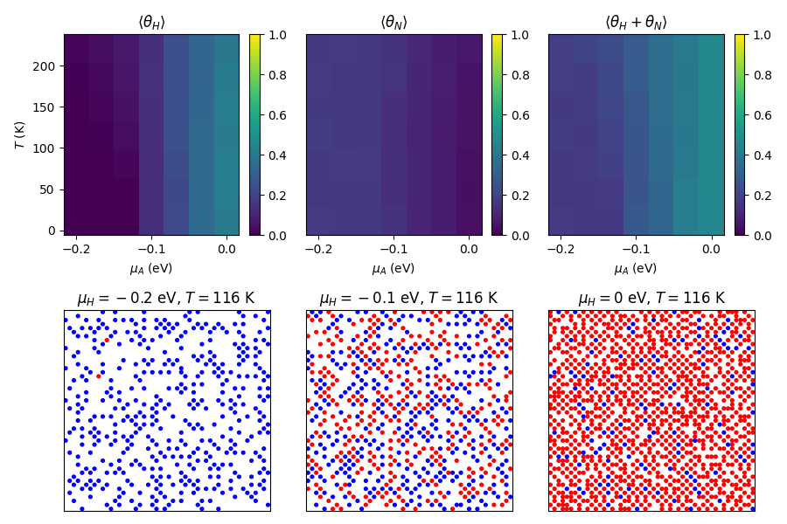

**Figure 2.** Phase diagrams and lattice configurations for repulsive interactions between nitrogen and hydrogen (lattice size: 50 × 50, blue circle represents nitrogen, red circle represents hydrogen).

**3.3 Attractive Interactions**

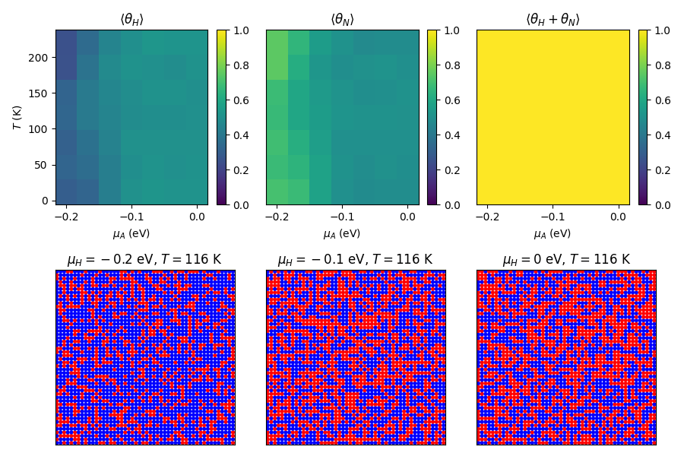

**Figure 3.** Phase diagrams and lattice configurations for attractive interactions between nitrogen and hydrogen (lattice size: 50 × 50, blue circle represents nitrogen, red circle represents hydrogen).

Opposed to the repulsive interactions scenario, gas particles tend to occupy lattice sites next to each other with attractive interactions (εNN = εHH= εNH= -0.05 eV), resulting in a higher total coverage on the lattice surface.

**3.4 Immiscible Nitrogen and Hydrogen**

In the immiscible nitrogen and hydrogen scenario, there is a repulsive interaction between nitrogen and hydrogen and an attractive interaction between the same type of particles (εNN = εHH= -0.05 eV, εNH= 0.05 eV). As a result, distinct phase separation was found in lattice configurations.

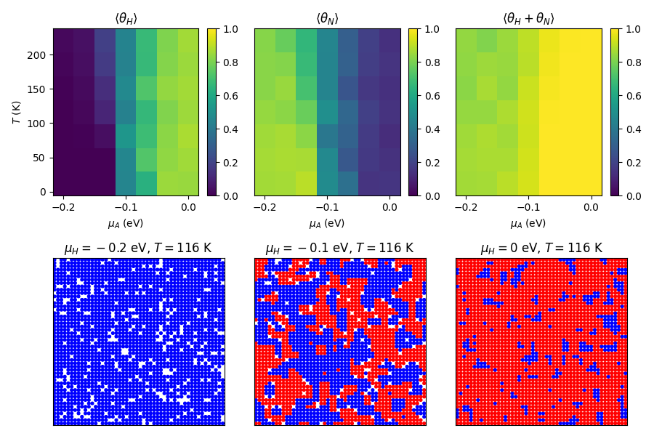

**Figure 4.** Phase diagrams and lattice configurations for immiscible nitrogen and hydrogen (lattice size: 50 × 50, blue circle represents nitrogen, red circle represents hydrogen).

**3.5 “Like Dissolves Unlike” Scenario**

In the “Like Dissolves Unlike” scenario, gas particles tend to be surrounded by particles of different types while facing repulsive interactions between the same type of particles (εNN = εHH= 0.05 eV, εNH= -0.05 eV), which leads to a checkerboard-like lattice configuration.

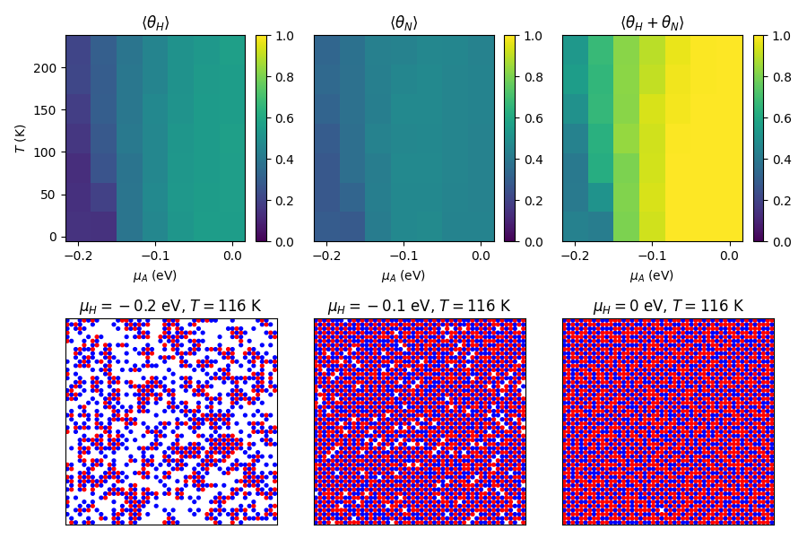

**Figure 5.** Phase diagrams and lattice configurations for the “Like Dissolves Unlike” scenario (lattice size: 50 × 50, blue circle represents nitrogen, red circle represents hydrogen).

1. **Discussion**

**4.1 Adsorption Behavior Analysis**

4.1.1 Nitrogen Adsorption Trends

The chemical potential of nitrogen was kept constant at -0.1 eV (*μ*N = -0.1 eV) in this GCMC simulation, so the coverage of nitrogen primarily depends on its interaction energies with itself (εNN) and with hydrogen (εNH), the chemical potential of hydrogen and temperature.

(1) The effect of interaction energy

The repulsive interactions between nitrogen and nitrogen/hydrogen will decrease the coverage of nitrogen, while the attractive interactions will do the opposite.

(2) The effect of the chemical potential of hydrogen

During competitive adsorption, coverage of nitrogen will decrease as the chemical potential of hydrogen increases, because higher chemical potentials will increase the driving force for adsorption, and as the adsorption of hydrogen becomes more favored, the adsorption of nitrogen will decrease during the competitive adsorption process.

(3) The effect of temperature

At higher temperatures, the coverage of nitrogen slightly decreases, which is a result of the higher kinetic energy of the particles at higher temperatures. As the temperature gets higher, the desorption rate will be higher because the system tends to minimize the Gibbs free energy, and entropy contribution (TΔS) becomes dominant at high temperatures.

4.1.2 Hydrogen Adsorption Trends

The adsorption of hydrogen showed a similar trend compared to nitrogen in terms of interaction energy and temperature. In the GCMC simulation, the chemical potential of hydrogen varied from -0.2 eV to 0 eV, and the coverage of hydrogen increased as its chemical potential increased. When the chemical potential of hydrogen is low, hydrogen adsorption is minimal due to insufficient driving force for adsorption.

**4.2 Comparison Between Parameter Sets**

4.2.1 Ideal Mixture

With εNN = εHH= εNH= 0 eV, both species behave independently, and the adsorption is determined solely by chemical potentials and temperature. In this case, coverage levels of nitrogen and hydrogen are governed by their respective chemical potentials. The higher chemical potential of hydrogen leads to higher hydrogen coverage, but without interaction energies, there is no direct influence of one species on the other's adsorption. As a result, the adsorption behavior aligns with Langmuir-like adsorption isotherm.

4.2.2 Repulsive Interactions

When there are high repulsive interactions between gas particles, a decreased total coverage is shown as the presence of one species hinders the adsorption of the other. For example, in the ideal mixture scenario, when the chemical potential of hydrogen is 0, the total coverage of nitrogen and hydrogen at the setting temperature range is about 1, however, in this repulsive interactions scenario, the total coverage drops to around 0.5

4.2.3 Attractive interactions

When there are attractive interactions between gas particles, the adsorption of one particle enhances the adsorption of the other, leading to a cooperative effect and resulting in an enhanced total coverage. In this case, the phase diagram shows a total coverage of nearly 1.0 at all temperatures and chemical potentials.

4.2.4 Immiscible Scenario

When interaction energy between nitrogen and nitrogen or hydrogen and hydrogen is negative, and between nitrogen and hydrogen is positive, nitrogen and hydrogen will prefer to adsorb in separate domains, because placing one particle among the different types of particles will cause great repulsive force and increase the system’s Gibbs free energy. As a result, this scenario leads to phase separation on the lattice surface.

4.2.5 “Like Dissolve Unlike” Scenario

In this scenario, mixed adsorption is encouraged while self-adsorption is discouraged, resulting in a uniform distribution of nitrogen and hydrogen on the lattice surface. This adsorption scenario would be favored in ammonia synthesis because it maximizes the contact area of nitrogen and hydrogen, facilitating the reaction.

**4.3 Effects of lattice size on the adsorption behavior and phase diagrams**

In the GCMC simulation, the effect of lattice size was studied in all scenarios, and the phase diagrams and lattice configurations are included in the supporting information.

For every scenario, when the size of the lattice is greater than a certain level (in this study, greater than 50 × 50), the total coverage of nitrogen and hydrogen will decrease. As the size of the lattice increases, the total number of available adsorption sites increases dramatically, while the chemical potential and temperature remain constant. This means that the average number of adsorbate particles remains unchanged, but they are distributed across a larger area, resulting in a lower overall coverage.

Also, in a large lattice, the average distance between particles increases, weakening the effective interactions between particles and making the lattice configurations of all scenarios resemble the ideal mixture scenario one.

**4.4 Implications for Ammonia Synthesis**

The results of the GCMC simulation offer significant insights for optimizing the ammonia synthesis via the Haber Bosch process.

1. Maximize co-adsorption and avoid repulsive interactions.

The simulation reveals that attractive interactions between nitrogen and hydrogen favor mixed adsorption on the catalyst surface, resulting in a higher total coverage of gas particles. By rational design of the surface property of the catalyst, the competitive adsorption process could achieve a higher total coverage of both nitrogen and hydrogen, increasing the reaction rate of ammonia synthesis.

1. Increase the pressure.

In the simulation, a higher chemical potential of hydrogen leads to a higher total coverage. So, in the industrial production of ammonia, a higher pressure of nitrogen and hydrogen would maximize the catalyst’s efficiency and push the reaction to the direction of the product. However, the partial pressure of one reactant should not greatly surpass the other, otherwise all the active sites on the catalyst surface will be occupied by one reactant and prevent the adsorption of the other reactant, resulting in a decreased reaction rate.

1. Control the reaction temperature

As the simulation shows, at a low temperature, adsorption is slightly enhanced for both nitrogen and hydrogen, leading to a higher total coverage. However, the kinetics of ammonia formation are slower at low temperatures due to the lower reaction rate. So, the reaction temperature needs to be carefully controlled to balance the trade-off between enhanced adsorption at low temperatures and higher reaction rates at high temperatures in the Haber-Bosch process.

1. **Conclusion**

In this project, we studied the competitive adsorption of nitrogen and hydrogen in the Harber-Bosch process by grand canonical Monte Carlo simulation. 5 different adsorption scenarios based on distinct interactions between gas particles were studied, as well as the effect of temperature and chemical potential of the hydrogen. These simulations provide a roadmap for improving catalyst design and optimizing reaction conditions, potentially leading to more efficient and sustainable ammonia synthesis.

**Supporting Information**

1. **Phase Diagrams and Lattice Configurations for Ideal Mixture of Nitrogen and Hydrogen.**

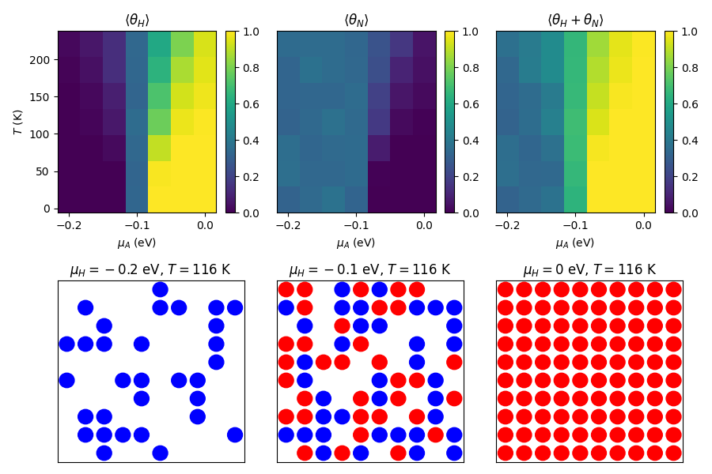

**Figure S1.** Phase diagrams and lattice configurations for ideal mixture of nitrogen and hydrogen (lattice size: 10 × 10, blue circle represents nitrogen, red circle represents hydrogen).

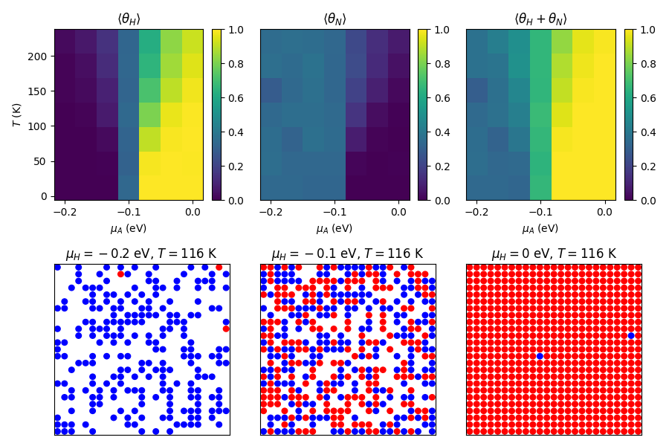

**Figure S2.** Phase diagrams and lattice configurations for the ideal mixture of nitrogen and hydrogen (lattice size: 25 × 25, blue circle represents nitrogen, red circle represents hydrogen).

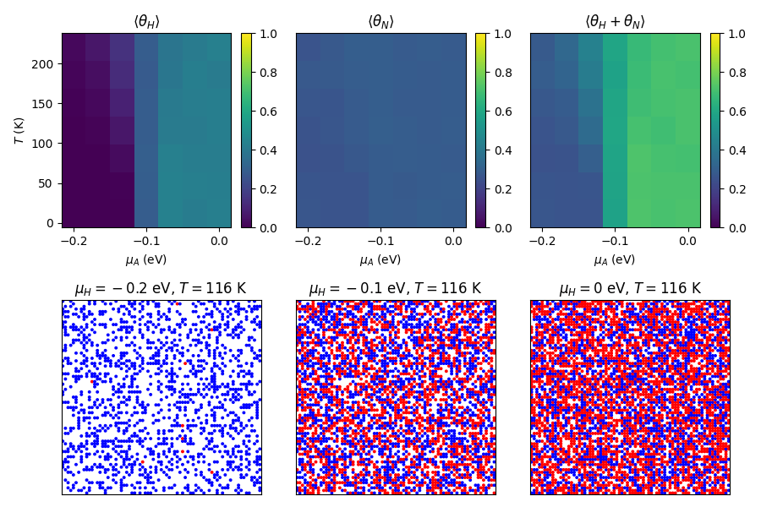

**Figure S3** Phase diagrams and lattice configurations for ideal mixture of nitrogen and hydrogen (lattice size: 75 × 75, blue circle represents nitrogen, red circle represents hydrogen).

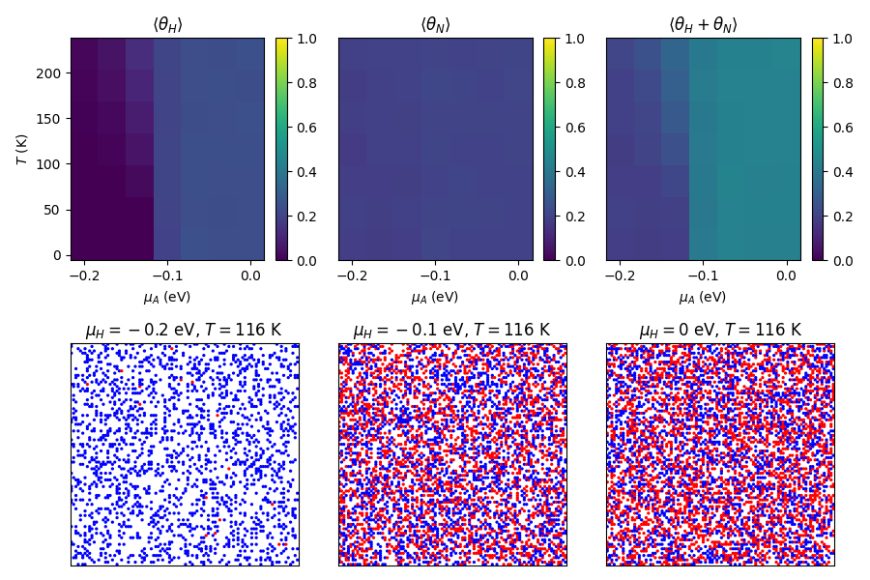

**Figure S4** Phase diagrams and lattice configurations for the ideal mixture of nitrogen and hydrogen (lattice size: 100 × 100, blue circle represents nitrogen, red circle represents hydrogen).

1. **Phase Diagrams and Lattice Configurations for Repulsive Interactions between Nitrogen and Hydrogen.**

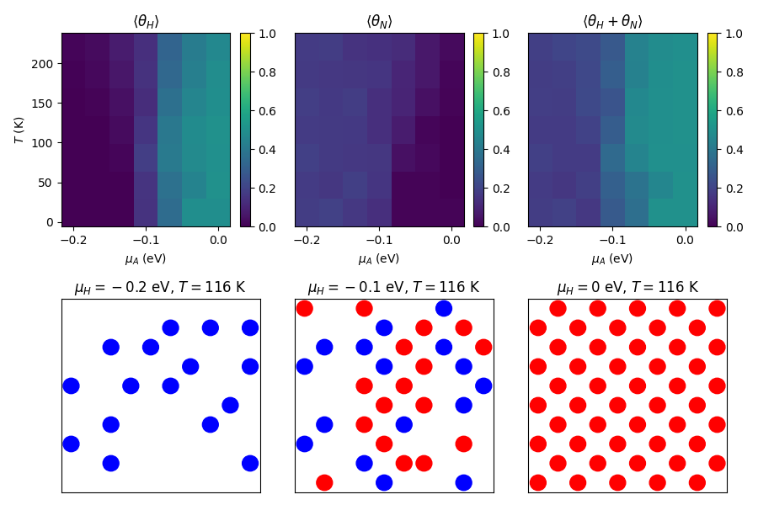

**Figure S5.** Phase diagrams and lattice configurations for repulsive interactions between nitrogen and hydrogen (lattice size:10 × 10, blue circle represents nitrogen, red circle represents hydrogen).

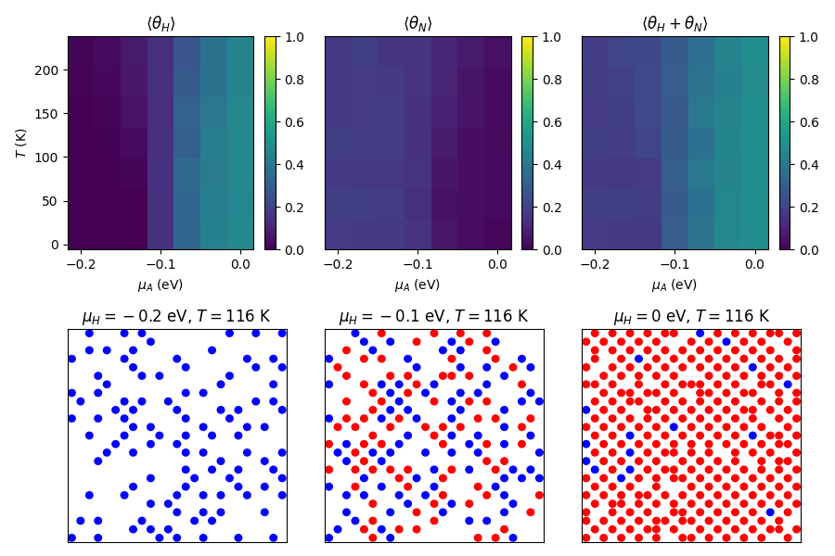

**Figure S6** Phase diagrams and lattice configurations for repulsive interactions between nitrogen and hydrogen (lattice size: 25 × 25, blue circle represents nitrogen, red circle represents hydrogen).

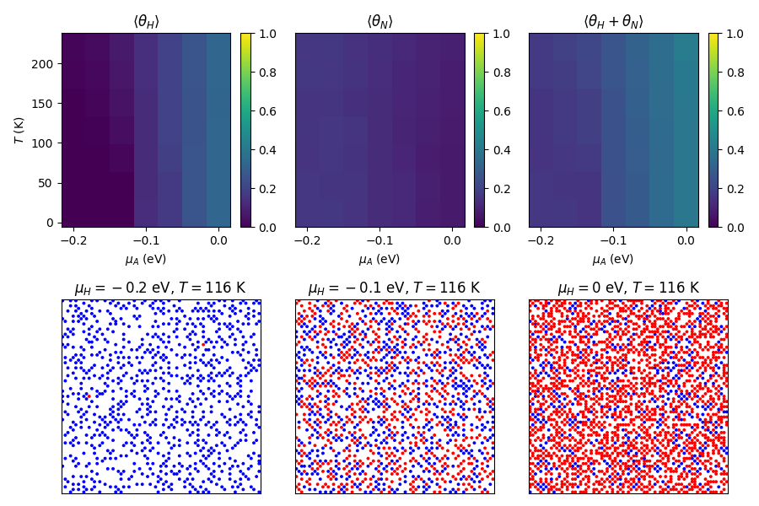

**Figure S7** Phase diagrams and lattice configurations for repulsive interactions between nitrogen and hydrogen (lattice size: 75 × 75, blue circle represents nitrogen, red circle represents hydrogen).

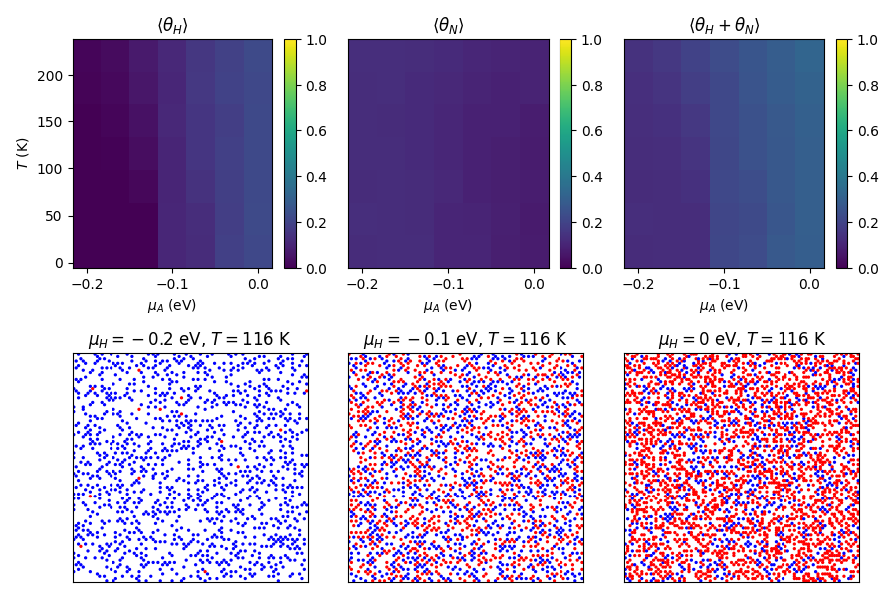

**Figure S8** Phase diagrams and lattice configurations for repulsive interactions between nitrogen and hydrogen (lattice size: 100 × 100, blue circle represents nitrogen, red circle represents hydrogen).

1. **Phase Diagrams and Lattice Configurations for Attractive Interactions between Nitrogen and Hydrogen.**

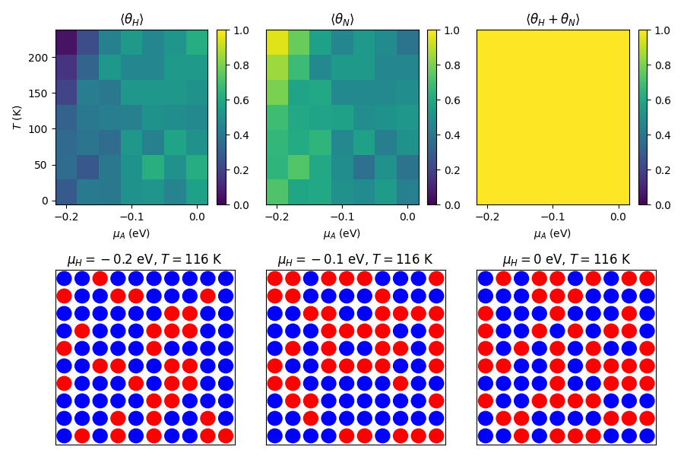

**Figure S9.** Phase diagrams and lattice configurations for attractive interactions between nitrogen and hydrogen (lattice size: 10 × 10, blue circle represents nitrogen, red circle represents hydrogen).

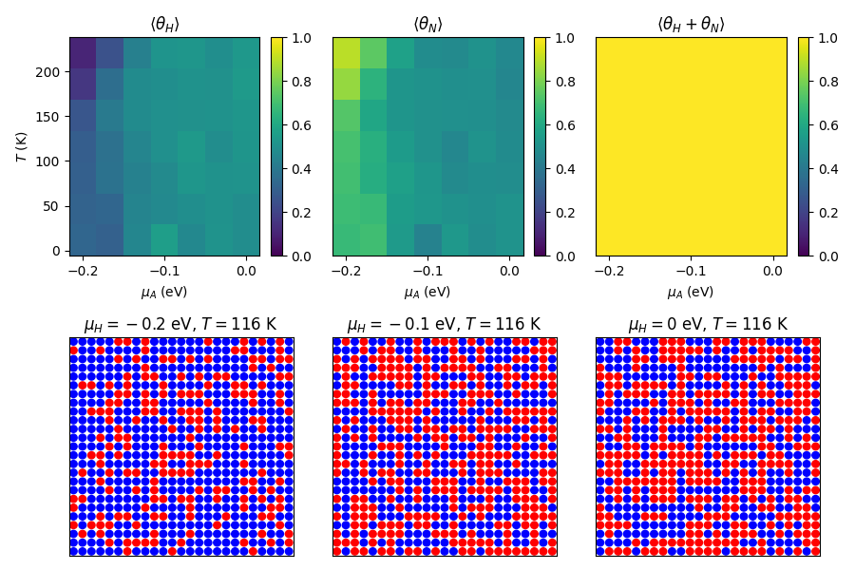

**Figure S10.** Phase diagrams and lattice configurations for attractive interactions between nitrogen and hydrogen (lattice size: 25 × 25, blue circle represents nitrogen, red circle represents hydrogen).

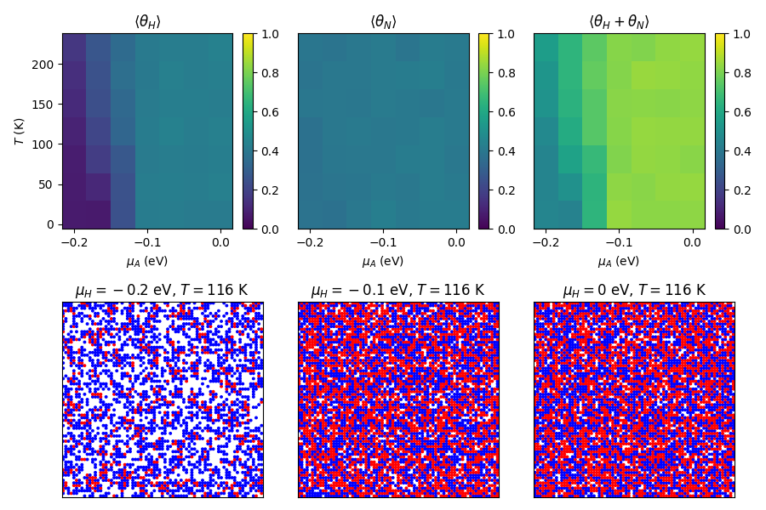

**Figure S11.** Phase diagrams and lattice configurations for attractive interactions between nitrogen and hydrogen (lattice size: 75 × 75, blue circle represents nitrogen, red circle represents hydrogen).

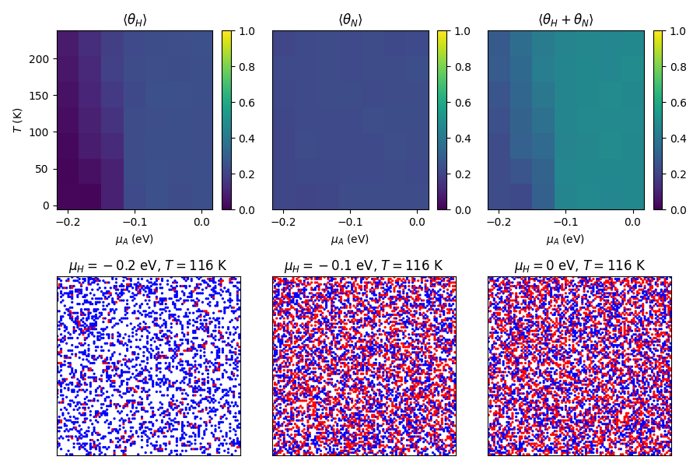

**Figure S12.** Phase diagrams and lattice configurations for attractive interactions between nitrogen and hydrogen (lattice size: 100 × 100, blue circle represents nitrogen, red circle represents hydrogen).

1. **Phase Diagrams and Lattice Configurations for Immiscible Nitrogen and Hydrogen.**

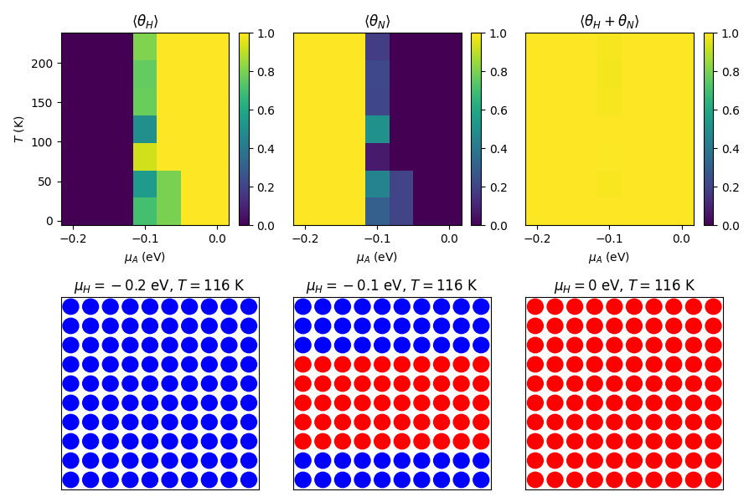

**Figure S13.** Phase diagrams and lattice configurations for immiscible nitrogen and hydrogen (lattice size: 10 × 10, blue circle represents nitrogen, red circle represents hydrogen).

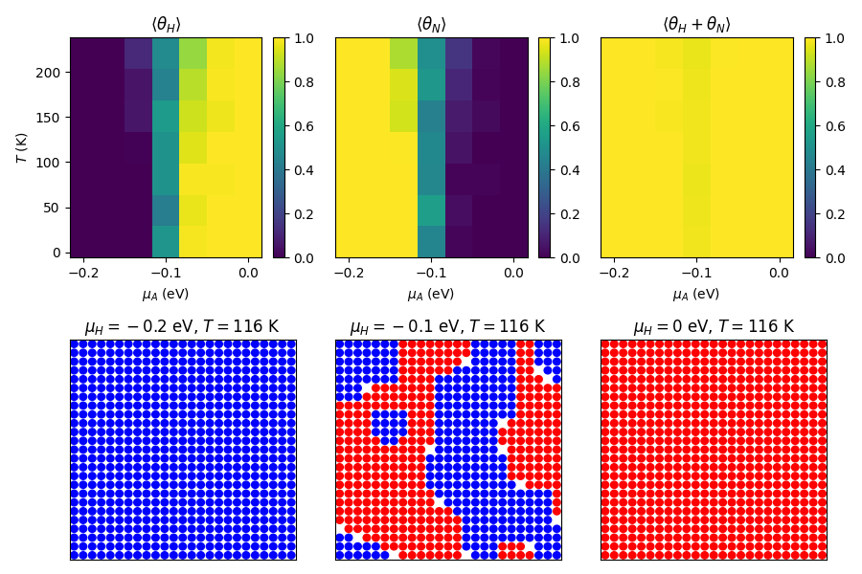

**Figure S14.** Phase diagrams and lattice configurations for immiscible nitrogen and hydrogen (lattice size: 25 × 25, blue circle represents nitrogen, red circle represents hydrogen).

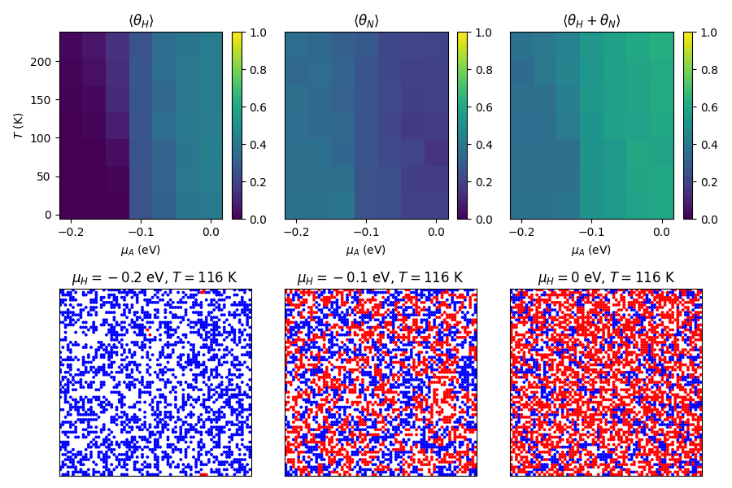

**Figure S15.** Phase diagrams and lattice configurations for immiscible nitrogen and hydrogen (lattice size: 75 × 75, blue circle represents nitrogen, red circle represents hydrogen).

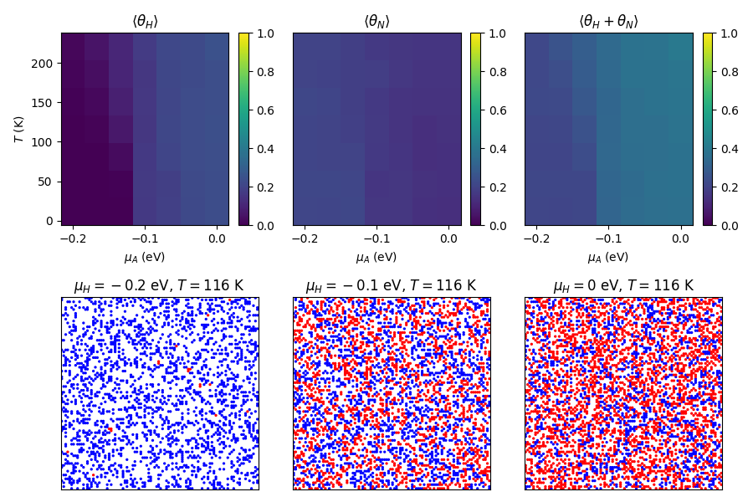

**Figure S16.** Phase diagrams and lattice configurations for immiscible nitrogen and hydrogen (lattice size: 100 × 100, blue circle represents nitrogen, red circle represents hydrogen).

1. **Phase Diagrams and Lattice Configurations for “Like Dissolves Unlike” Scenario.**

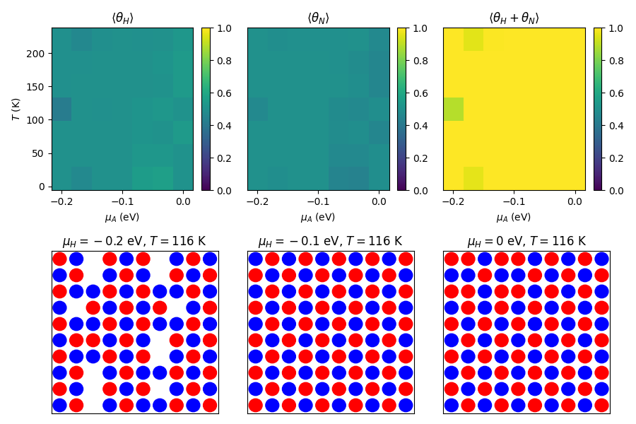

**Figure S17.** Phase diagrams and lattice configurations for the “Like Dissolves Unlike” scenario (lattice size: 10 × 10, blue circle represents nitrogen, red circle represents hydrogen).

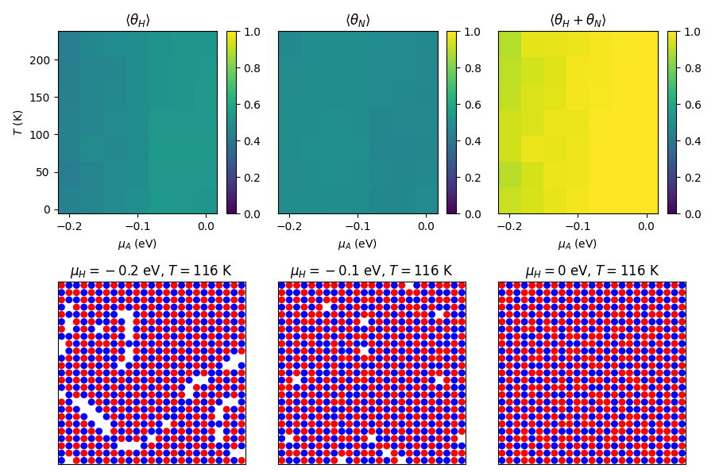

**Figure S18.** Phase diagrams and lattice configurations for the “Like Dissolves Unlike” scenario (lattice size: 25 × 25, blue circle represents nitrogen, red circle represents hydrogen).

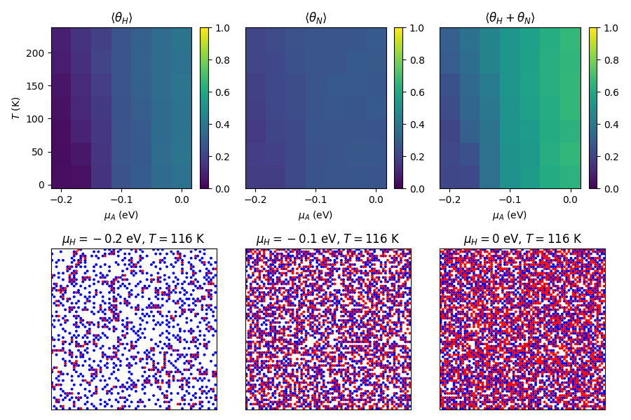

**Figure S19.** Phase diagrams and lattice configurations for the “Like Dissolves Unlike” scenario (lattice size: 75 × 75, blue circle represents nitrogen, red circle represents hydrogen).

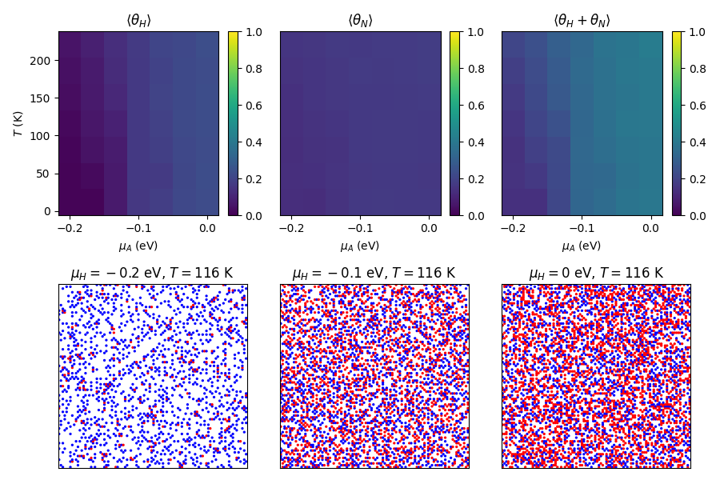

**Figure S20.** Phase diagrams and lattice configurations for the “Like Dissolves Unlike” scenario (lattice size: 100 × 100, blue circle represents nitrogen, red circle represents hydrogen).